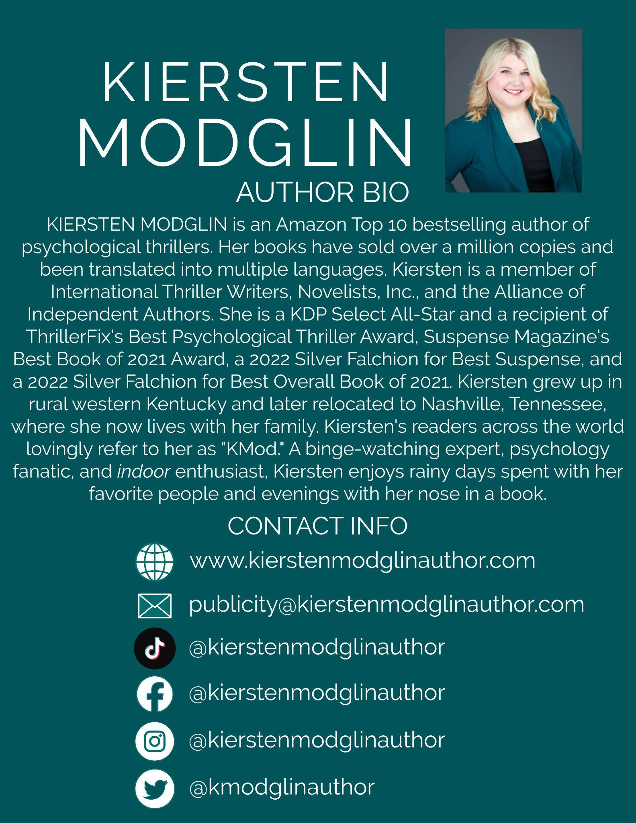
AUTHOR BIO:

KIERSTEN MODGLIN is an Amazon Top 10 bestselling author of psychological thrillers. Her books have sold over a million copies and been translated into multiple languages. Kiersten is a member of International Thriller Writers, Novelists, Inc., and the Alliance of Independent Authors. She is a KDP Select All-Star and a recipient of ThrillerFix's Best Psychological Thriller Award, Suspense Magazine's Best Book of 2021 Award, a 2022 Silver Falchion for Best Suspense, and a 2022 Silver Falchion for Best Overall Book of 2021. Kiersten grew up in rural western Kentucky and later relocated to Nashville, Tennessee, where she now lives with her family. Kiersten's readers across the world lovingly refer to her as "KMod." A binge-watching expert, psychology fanatic, and indoor enthusiast, Kiersten enjoys rainy days spent with her favorite people and evenings with her nose in a book.

PRESS:

Modglin Talks to ManyBooks.net About Debut If It Walks Like A Killer
Fireside Chat with Kiersten Modglin
Talking Thrillers with Award-Winning Author Kiersten Modglin
Suspense Star Kiersten Modglin joins Bookouture
Modglin discusses writing The Arrangement with ManyBooks.net
Author Spotlight: Kiersten Modglin
Meet the Thriller Author Podcast: Episode 151, Kiersten Modglin
​Author Workspace: Kiersten Modglin
The Growing Popularity of Domestic Thrillers: An Article by Kiersten Modglin,
​Featured in Mystery and Suspense Magazine
The Sh*t No One Tells You About Writing Podcast:
What it Takes to be a Successful Indie Author w/Kiersten Modglin
Killer Content Podcast: Kiersten Modglin
Kiersten Modglin discusses Just Married with The Big Thrill Magazine
Author Spotlight: Kiersten Modglin "The Queen of Twists"​

The Book Reporters Podcast: The Reunion by Kiersten Modglin

The Book Reporters Podcast: Widow Falls by Kiersten Modglin

The Book Reporters Podcast: Our Chat with Kiersten Modglin

ABC News: The Missing ranked #7 Fiction Audiobook on Audible

What Angela Reads Podcast: Kiersten Modglin discusses Tell Me the Truth

AJ Wills: Quickfire Q & A with Author Kiersten Modglin

Writing Shaped My Life: Kiersten Modglin

BookyBabe Interview: Kiersten Modglin Part 1
​
Nashville Rising Stars: Kiersten Modglin

Author Interview: Kiersten Modglin

Video Review: The Dinner Guests

​BookyBabe Interview: Kiersten Modglin Part 2

Author Taste Test: Kiersten Modglin

Successful Thriller Authors Panel at 1455 SummerFest

Kiersten Modglin’s The Reunion wins two Silver Falchions: Best Book of 2021 and Best Suspense

True Crime and Authors Podcast: Kiersten Modglin

Olivia’s Book Club: A Quiet Retreat with Kiersten Modglin​

Talk Bookish To Me: Kiersten Modglin

A Quiet Retreat praised by Library Journal: "...an intricate, eerie suspense novel teeming with tension and twists."

CONTACT INFO:
www.kierstenmodglinauthor.com
publicity@kierstenmodglinauthor.com
www.facebook.com/kierstenmodglinauthor
www.instagram.com/kierstenmodglinauthor
www.tiktok.com/@kierstenmodglinauthor
www.twitter.com/kmodglinauthor

ACCOLADES:
The Arrangement #1 New Release in Psychological Fiction 4 weeks in a row
I Said Yes voted #1 Psychological Thriller of Winter 2020 by Thrillerfix.com
The Arrangement viral TikTok reaches 3 million viewers
Widow Falls viral TikTok reaches 2 million viewers
The Arrangement voted a Best Book of 2021 by Suspense Magazine
The Reunion #1 New Release in Psychological Fiction within 24 hours of release
The Missing #7 Best Selling Audiobook on Audible according to ABC News
The Family Secret #1 New Release in Psychological Fiction 4 weeks in a row
The Reunion received a Silver Falchion for Best Suspense and Best Overall Book of 2021
A Quiet Retreat praised by Library Journal: “...an intricate, eerie suspense novel teeming with tension and twists. Recommended for fans of Marin Montgomery, Mary Kubica, and Rachel Hawkins.”

SAMPLE QUESTIONS FOR KIERSTEN:
-What made you decide to self-publish?
-What is your favorite part of being a writer?
-When did you know you wanted to be a writer?
-What’s your writing process?
-You’re very prolific. Tell me about how you write so quickly.
-Which of your books is your favorite?
-Where do you come up with your ideas?
-Growing up, could you ever imagine being where you are today?
-What advice do you have for aspiring writers?
-Who are some of your favorite authors?
-What do you hope readers get from your books?
-Your readers have dubbed you ‘The Queen of Twists,’ how do you manage to keep the twists coming?
-Do you ever get writer’s block?

AGENT’S CONTACT INFO:
Carly Watters
carly@psliterary.com
https://www.psliterary.com/

FILM AGENT’S CONTACT INFO:
Olivia Burgher
oburgher@wmeagency.com
https://www.wmeagency.com/

If you would like to ask any additional questions, request a media kit for a specific book, or schedule an interview, please don’t hesitate to reach out.

